International Castle Research Society (ICRS)
Grindelweg 4

D-52076 Aachen (Germany)

Traveling Exhibitions “French Donjons” and “Castles and Bazars of the Crusader Age”

Dear madam, dear Sir,

You may remember the ICRS wrote to you some time ago mentioning our two exhibitions and calling your attention to our ICRS-stand at the AAM Annual Meeting 2004 in New Orleans.
We can now give you some more detailed information on our two exhibits, i.e. French Donjons and Castles and Bazars of the Crusader Age.
Since 1998, French Donjons has attracted some 500,000 quite enthusiastic visitors in 18 different places.
The model of “Donjon of Coucy” allows an excellent first glimpse at the history of the Middle Ages in Europe. It is 19 x 19 feet by 8 feet high and has some 2,500 individually hand-crafted and hand-painted figurines, the scale of 1 . 25. It shows different aspects of the siege of a medieval castles as well as scenes from the daily life of a feudal lord and his vassals and ordinary work people.
In addition to this model there is another, “French Knightly Tournament”, also scale 1:25, appr. 7 x 7 feet, using some 700 figurines.
Both models have protective glass coverings. There are 52 information boards complete with pictures, diagrams and descriptive texts providing general information as well as highlighting some of the most spectacular donjons from among the 1.085 donjons in France we know of.
This whole exhibit takes up some 3000 sq. metres.
In 2001, this exhibit was shown at the Museum of the National Geographic Society, attracting some 40.000 people. At the moment, up till November 30, 2005, it is being exhibited in the unique donjon of the château of Sully-sur-Loire, France. From there, the exhibit will move to Omaha, Nebraska’s Joyslyn Art Museum, to be shown Januar 20 through May 15, 2006.

We also have the exhibit Castles and Bazars of the Crusader Age. It has some 50 information boards and two models, “Siege of the Crac des Chevaliers Castle” and “Aleppo Bazar”. This exhibition will be opened on November 5, 2005, in the Archaeological Museum of Frankfurt-on-the Main, Germany, then in the Museum of the National Geographic Society, Washington, DC, from April 4, 2006 through September 4, 2006.
The centrepiece of this exhibit is a model of Crac des Chevaliers, taking up 19 x 19 feet at a scale of 1:25. Several thousand figurines demonstrate the site illustrating the period when the castle was besieged and eventually taken by Qalawun, the Mamluk sultan, in 1271. The exact point in time shown is the last stage of the siege, when the outer walls have been undermined and the assaillants using siege machines and ladders have almost reached the central castle.
The other model, “Aleppo Bazar” depicts life at an Oriental market in medieval times, using some 750 figurines and thousands of additional elements displayed on a base of 13 x 13 feet.

In this context, we would like to put to you the following question :
Would you be interested in showing either exhibit, “French Donjons” and “Castles and Bazars” at your Museum ?
Ideally, we are thinking of a combination of both exhibitions, the one to be arranged at one year’s interval from the other. That of course would be left for you to decide.

Following on the exhibitions to be held at Washington DC and Omaha, Nebraska, there are plans for a tour of the USA and Canada which we would very much welcome.

There is a catalogue “French Donjons” in four languages, also a DVD containing TV reports on the exhibits, as well as a promotional video with commentaries in three languages which you can purchase at cost price.
In addition to this, for further information please visit our homepage, www.burgenkunde.de, which also is in three languages.

Hoping our offers have your eye,
We remain,

Yours sincerely,

Bernhard Siepen Claudia Buchsteiner
Director Head of Public Relation

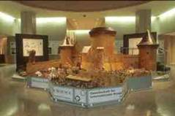 | 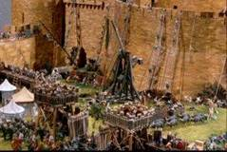 | 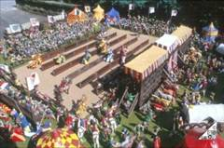
Current Exhibition „French Donjons“
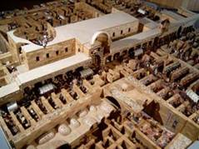  Model „Aleppo Bazar“ | 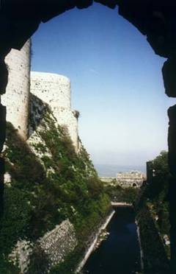 | 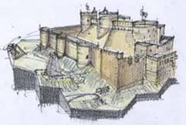
Model „Crac des Chevaliers“
under construction
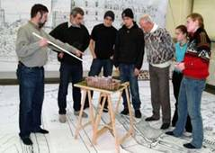
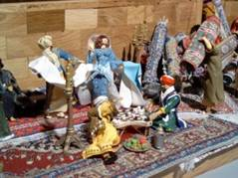
New Exhibitions “Castles and Bazars of the Crusader Age”

